**PORTWORX ISSUES AND TROUBLESHOOTING STEPS**

1. If you are unable to see the cloudsnap backups with the error: **Client timeout exceeded** or if the session is getting timed out, then try to see the CS backups with the volume ID instead of volume name.

**pxctl cs l --cred-id <cred-id> <volume-id>**

In case session is getting timed out with volume-id also, then try to view if backups are creating fine or not using below command:

**pxctl cs status | grep <volume-name/volume-id>**

This will show if backups are at least getting created or not without mentioning if it is Daily CS backup or Periodic. Look for the date and time in the list and figure out if it is creating fine or not.

1. If any of the portworx volume backup is failed/missing, report it in health check report as usual and take a manual backup with below command

* Local Backup Manually:

**pxctl volume snapshot create --name snapshotname volumename**

Example for snapshotname: volumename_dateandtime

* Cloud Backup Manually:

**pxctl cs backup --cred-id <cred-id> -f <volume-name>**

* Additional Troubleshooting Commands:

**systemctl status portworx** → To check if portworx service is running on that node

**systemctl start portworx** → To start the portworx service if it is in stopped/inactive state

**systemctl restart portworx** → To restart the portworx service if there is some issue with it

Please send out an email immediately to our team if you find any issues with Portworx local and external backups with error screenshot.

1. Steps to check the issue behind the failed backups:

**NOTE: For **ITG2** backups, whenever a node is rebooted in DCOS ITG1, we might see an issue with Miniod service and if a node is rebooted in DCOS ITG2, we might face issues with portworx service. In Case of **PROD1** backups, whenever a node is rebooted in DCOS PROD2, we might see an issue with Miniod service and if a node is rebooted in DCOS PROD1, we might face issues with portworx service.

**pxctl cs status | grep -E "Backup-Failed"** → To see which backups are failing.

**pxctl cs status -n <cs_name> -j** → To check the error with which the backups are failing.

Here, replace <**cs_name**> with the cs name of the failed backup obtained with previous command.

* If backups are failing with below error:

  "Info": [

   "SerializationError: failed to decode S3 XML error response\n\tstatus code: 503, request id: , host id: \ncaused by: expected element type \u003cError\u003e but have \u003chtml\u003e"

  ],

**OR**

  "Info": [

   "SlowDown: Please reduce your request\n\tstatus code: 503, request id: 1637725364F6F5F6, host id: "

  ],

**OR**

"Info": [

   "RequestError: send request failed\ncaused by: Put <https://minio-dcos.dc02.its.hpecorp.net:9000/colo1-prod-cloudsnap-backups/2840344191526466-561619078809275590/5>: EOF"

  ],

Validate creds as mentioned in step VI.

* If validations are **successful**, then we need to check if the tasks of miniod service are restarting continuously and if redeployment is needed in Colo2 DCOS Prod.
* If validations on any node in **unsuccessful,** then restart portworx service on the particular node and validate on remaining nodes also.If this issue still persists, then **portworx-miniod** service redeployment is required in DCOS PROD 2 or DCOS ITG 1 for backups issue in DCOS PROD 1 and DCOS ITG 2 respectively.

1. When you get below error while checking cloudsnap backups OR while checking the error with which the backups are failing (pxctl cs status -n <cs_name> -j)

Info": [

"Not authenticated with the secrets endpoint on cea6036b-69d2-469a-ac82-22366f40fff8"

],

Validate creds as mentioned in step VI.

* If validations are **successful**, then we need to check if the tasks of miniod service are restarting continuously and if redeployment is needed in Colo2 DCOS Prod.
* If validations on any node is **unsuccessful,** then we need to restart portworx service on that node: **sudo** **systemctl restart portworx**

1. Whenever you see **Serialization error** while checking portworx backups, please validate credentials once:

**pxctl cred validate <cred-id>**

 If creds are not getting validated with the same Serialization error, you need to redeploy portworx miniod service on the cluster where cloud backups are getting stored, i.e, in Colo1 DCOS ITG or Colo2 DCOS Prod.

1. **Credentials Validation**

Validation of creds should be done both ways, i.e., from Colo1 to Colo1, Colo1 to Colo2 in Colo1 private nodes and from Colo2 to Colo1 and Colo2 to Colo2 in Colo2 private nodes using below command:

**pxctl cred validate <cred-id>**

*To get these cred-ids, run the command: **pxctl cred list**

*For instance*, if you see the above error in Colo1 DCOS Prod node, then run below commands in all Colo1 Prod private nodes:

Colo1 to Colo1: **pxctl cred validate** **COLO2-DCOS-PROD-PWX-MINIO**

Colo1 to Colo2: **pxctl cred validate COLO2-DCOS-PRODDR-PWX-MINIO**

And below commands in all Colo2 Prod private nodes:

Colo2 to Colo1: **pxctl cred validate COLO2-DCOS-PROD-PWX-MINIO**

Colo2 to Colo2: **pxctl cred validate COLO2-DCOS-PRODDR-PWX-MINIO**

Similarly, validate creds if you see issue in Colo2 DCOS ITG backups.

1. **Redeployment of Miniod Service**:

Redeployment should be done in DCOS ITG 1 for issues faced in DCOS ITG 2 and in DCOS PROD 2 for issues faced in DCOS PROD 1.

1. In DCOS dashboard, go to [**portworx-miniod**](https://dashboard-itg-dcos.dc01.its.hpecorp.net/#/services/detail/%2Fportworx-miniod) service under **Services** tab and click on edit button.

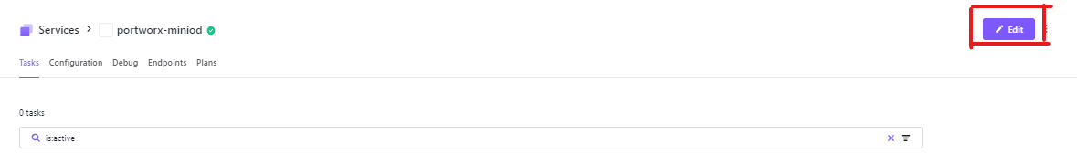

Click on the JSON button on the right of the dashboard and copy the entire content on JSON file and paste it on any editor for future use.

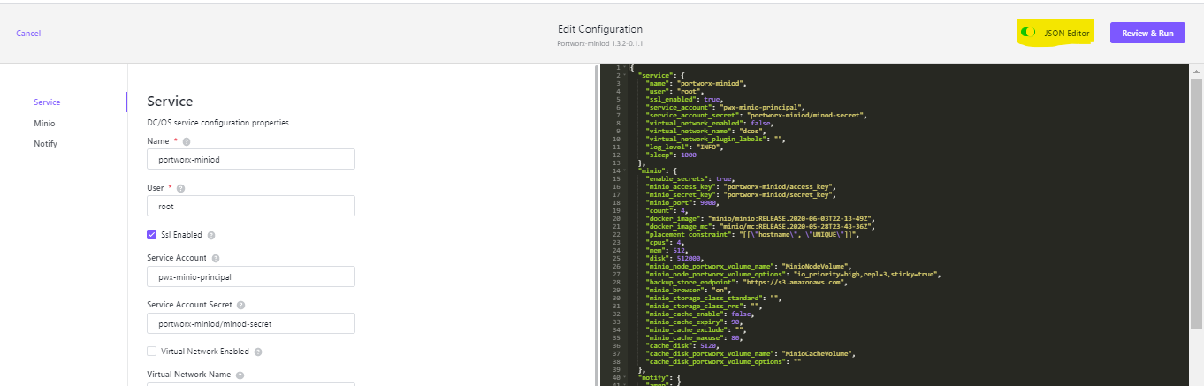

Click on Cancel button on the left of the dashboard and select Discard.

Once back to the service dashboard, click on the 3 dots beside the Edit button and select delete and confirm.

1. Once the miniod service is completely deleted from the dashboard, look for the list of services from DCOS CLI to see if the **portworx-miniod** service has been removed completely (command: **dcos service** ). If the service is not present in the list then it is removed.
2. Now log in to any private node in that cluster and check if the miniod volumes are detached from all nodes.

**pxctl volume list | grep Minio**

If for some volume you can see it is still attached on some node, you need to detach it.

**pxctl volume inspect <volume name/volume id>**

**pxctl host detach <volume name/volume id>**

When any volume is not detached from the node, get the node rebooted by raising a request to Infra team. If still the volume is attached even after reboot, run

**pxctl host detach <volume name/volume id> --redirect**

and see if all the volumes of Minio service is completely detached or not.

1. Check if there is any data present in the zookeeper for portworx minod framework.

<https://dashboard-dcos.dc02.its.hpecorp.net/exhibitor>

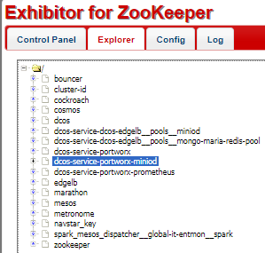

If you see dcos-service-portworx-miniod is present, then run janitor script from one of the masters to completely clean it up. Make sure all volumes are detached before running the script.

**docker run mesosphere/janitor /janitor.py -r portworx-miniod-role -z dcos-service-portworx-miniod**

1. Go to the Catalog tab in the dashboard, and search for ‘miniod’ and select below highlighted service named ‘portworx-miniod’ and select **Review & Run** in the nexttab.

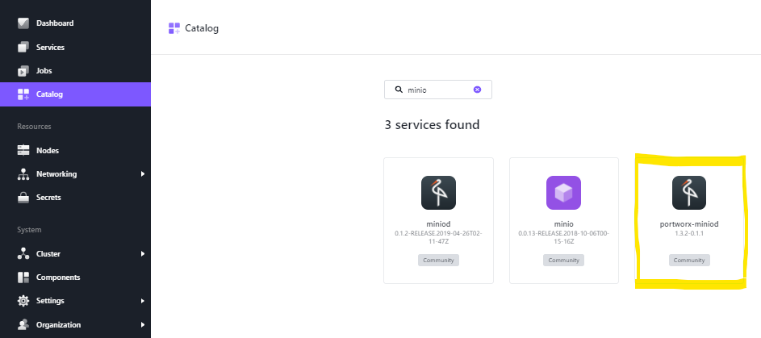

Click on JSON editor and replace the JSON file content with the JSON file we copied in step 1. Click on **Review & Run** and then **Run Service.** It will take some time to be deployed and start all the tasks.

\***Note**: Post redployment of miniod service, please do not try to validate creds for atleast 3-4 hours in ITG and for atleast a day or so in PROD. Validating creds immediately after redeployment sends request to the cluster where redeployment is done which may cause issue and we might need to redeploy miniod service again.

\***Note**: Post reboot of any private node in DCOS cluster, make sure to restart portworx on that node.

1. **File System errors in Portworx Volume**

As a precautionary step, we should take a snapshot and clone of the volume and perform the troubleshooting steps on the cloned volume and then on the original volume if there are any file system errors.

**Note :** MinioNodeVolume-3 is a portworx volume name used for reference in below commands.

Take a snapshot of the volume.

**pxctl volume snapshot create –name MinioNodeVolume-3-snap MinioNodeVolume-3**

Clone the volume.

**pxctl volume clone --name MinioNodeVolume-3-clone MinioNodeVolume-3**

Attach the cloned volume.

**pxctl host attach MinioNodeVolume-3-clone**

Run file system consistency check on the linux file system which is attached to the cloned volume in previous step. (-n flag prints the errors but not fixes those)

**sudo fsck -n /dev/pxd/pxd181147006061635499 > /tmp/fsckoutput-MinioNodeVolume-3**

check errors if any.

**cat /tmp/fsckoutput-MinioNodeVolume-3**

Fix the file system errors. (-y flag is yes to all)

**sudo fsck -y /dev/pxd/pxd181147006061635499 > /tmp/fsckoutput1-MinioNodeVolume-3**

check the errors if any.

**cat /tmp/fsckoutput1-MinioNodeVolume-3**

Mount the cloned volume to check data.

**sudo /opt/pwx/bin/pxctl host mount --path /var/lib/osd/mounts/temp MinioNodeVolume-3-clone**

check for lost+found. if there is no lost+found, then there is no data loss after fixing file system errors.

**ls -lrth /var/lib/osd/mounts/temp/colo1-prod-cloudsnap-backups/**

Unmount the cloned volume.

**sudo /opt/pwx/bin/pxctl host unmount --path /var/lib/osd/mounts/temp MinioNodeVolume-3-clone**

Detach the cloned volume.

**pxctl host detach MinioNodeVolume-3-clone**

Proceed the same steps for the original volume if the above steps are successful.

**Portworx Reference Docs :**

<https://docs.portworx.com/>

<https://docs.portworx.com/install-with-other/dcos/operate-and-maintain/going-production-with-dcos/>

<https://docs.portworx.com/reference/cli/>

<https://docs.portworx.com/reference/cli/create-and-manage-volumes/>

**ADDITIONAL COMMANDS:**

1. Create a volume

**pxctl volume create <volumename>->** Returns the id of the volume created

1. Create a storage volume in a Portworx storage cluster

**docker volume create -d pxd --name <volumename>**

1. To off sticky for a volume

**pxctl volume update <volumename> --sticky=off**

1. Delete a volume

**pxctl volume delete <volumename>**

1. List all the volumes in a cluster

**pxctl volume list** OR **pxctl v l**

1. Create snapshots of volumes

**pxctl volume snampshot create –name <snapshot-name>**

1. Delete snapshot

**pxctl volume delete <snapshot-name>**

1. To restore a volume from its snapshot

**pxctl volume restore –snapshot <snapshot-name> <new/existing-volume-name>**

1. Inspect a volume

**pxctl volume inspect <volumename/id>**

1. To validate cloud credentials

**pxctl credentials validate <uuid or cred-id>**